**EXPERIMENT NO. - 5**

**AIM:** To cut a slot on CNC milling machine as per given drwing.

**TOOL USED**:- CNC Milling machine, Flat mill cutter (dia 6.00mm), & vernier caliper.

**MATERIAL**:- Aluminum plate 100*100*10(mm)

**DIAGRAM & CORDINATES:-** 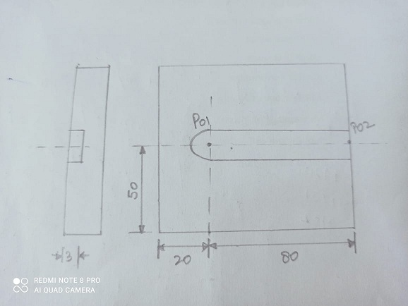

**PART PROGRAM:-**

01245;

N10 G28 X0.0 Y0.0 Z0.0;

N20 G90 G21 G94 F50;

N30 M06 T0202;

N40 G97 S1000 M03;

N50 G00 X20 Y50 Z5 M08;

N60 G01 X20 Y50 Z-3;

N70 G01 X100 Y50 Z-3;

N80 G01 X100 Y50 Z-6;

N90 G01 X20 Y50 Z-6;

N110 G00 X20 Y 50 Z5;

N120 G28 X0 Y0 Z0;

N130 M05 M09;

G140 M30;

**G00:-**Rapid transverse

**G01:-**Linear interpolation

**PROCEDURE:-**

1. Write the program for the desired job
2. Clamping the job in vice of NC machine
3. Take offset setting.
4. Simulating the program on C.R.T
5. Editing of the program if required.
6. Simulation of program after editing if needed.

**REMARKS:**

The program is used for cutting desired shape. Depth given by Z. after that tool will return to reference position.